Physical Science Year 7

Topic Test

Name: _______________________________________ Total: 65 marks

Part A: Multiple-Choice (10 marks)

1. A force is applied when something is:

**A** pushed, pulled or torn.

**B** pulled, pushed or twisted.

**C** twisted, pulled or attracted.

**D** pushed, twisted or torn.

2. A force can change:

**A** the direction something is moving.

**B** the speed something is moving at.

**C** the shape of an object.

**D** all of the above.

3.Which of the following is **correct**:

**A** the more massive something is, the greater its inertia.

**B** the less massive something is, the greater its inertia.

**C** the more massive something is, the less its inertia.

**D** the mass of something has no effect on inertia.

4. **Active** safety features are designed to reduce the chance of an accident happening. **Passive** safety features lessen the possible damage to the occupants when an accident **does** happen.

Which of the following are all **active** safety features?

**A** good tyres, anti-lock brakes, airbags.

**B** electronic stability control, good tyres, reversing sensors.

**C** seatbelts, airbags, crumple zones.

**D** seatbelts, good tyres, reversing sensors.

5. Which of the following are **all** methods to reduce friction?

**A** adding weight, rough surfaces, polishing.

**B** rough surfaces, wheels, lubricants.

**C** lubricants, air-layers, streamlining.

**D** polishing, increase surface area, rough surfaces.

6. Which of the following statements about gravity is true?

**A** gravity is a contact force.

**B** gravity pushes objects towards the Earth.

**C** all objects naturally attract each other.

**D** all of the above.

7. Atoms are made up of the following subatomic particles:

**A** protons, neutrons and electrons.

**B** positive, neutrons and electrons.

**C** protons, negatives and electrons.

**D** protons, negatives and static.

8. Static electricity occurs when:

**A** insulators move from one charged object to another.

**B** neutrons move from one charged object to another.

**C** protons move from one charged object to another.

**D** electrons move from one charged object to another.

9. If the following forces are acting on an object it will move:

|  |  |  |  |
| --- | --- | --- | --- |
| Force to left (N) | Force to right (N) | Force upwards (N) | Force downwards (N) |
| 20 | 30 | 0 | 0 |

**A** right.

**B** left.

**C** upwards.

**D** downwards.

10. A wheelbarrow is an example of a:

**A** first-class lever.

**B** second-class lever.

**C** third-class lever.

**D** fourth-class lever.

**Part 2: Short Answer**

1. **Match** the following terms with their correct meaning. Note: not all words will be used.

Force, Newton, friction, lubricant, gravity, mass, weight, non-contact force, contact force,

atoms, insulator, conductor, poles, repel, attract, balanced force, unbalanced force, inertia,

aurora, magnetic field.

a) The amount of matter in an object ____________________________________________

b) Allows electrons to flow through _____________________________________________

c) When two forces are equal and opposite ________________________________________

d) The unit used to measure forces ______________________________________________

e) The ends of a magnet ______________________________________________________

f) A contact force present when two objects are in contact ___________________________

g) The tendency of an object in motion to continue moving ___________________________

h) A force of attraction between two objects ______________________________________

i) When two poles push each other away ________________________________________

j) A spectacular light show near the poles ________________________________________

(10 marks)

2. a) **Draw** and **label** how a north and north pole, south and south pole and north and south

pole react when being placed near each other:

(4 marks)

b) **Describe** how friction can be both useful and a nuisance. Give examples ________________

___________________________________________________________________________

___________________________________________________________________________

___________________________________________________________________________

(4 marks)

3. Simple machines can make a task easier:

1. **State** two ways they can make a task easier _____________________________________

________________________________________________________________________

1. **Name** two simple machines _________________________________________________

(4 marks)

4. **Justify** the following statement:

1. It is easy to reduce friction.

___________________________________________________________________________

___________________________________________________________________________

___________________________________________________________________________

___________________________________________________________________________

(2 marks)

5. **Explain** how mass is different to weight __________________________________________

___________________________________________________________________________

___________________________________________________________________________

___________________________________________________________________________

(2 marks)

6. **Classify** the following as contact or non-contact:

1. gravity _______________________________________________
2. friction _______________________________________________
3. electrostatic ___________________________________________
4. magnetic _____________________________________________

(4 marks)

7. **Identify** whether the following are increasing or decreasing friction:

1. Oil in an engine ____________________________________________________
2. Tread on a tyre _____________________________________________________
3. Polishing the bottom of a boat_________________________________________

(3 marks)

8. The following picture shows a type of simple machine:

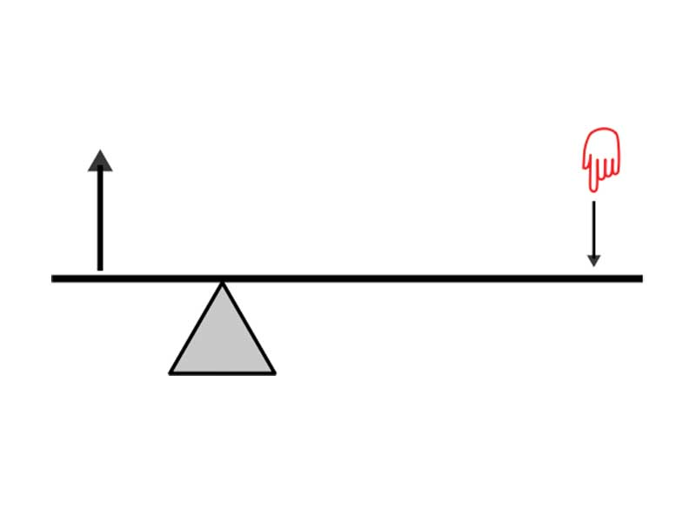

B

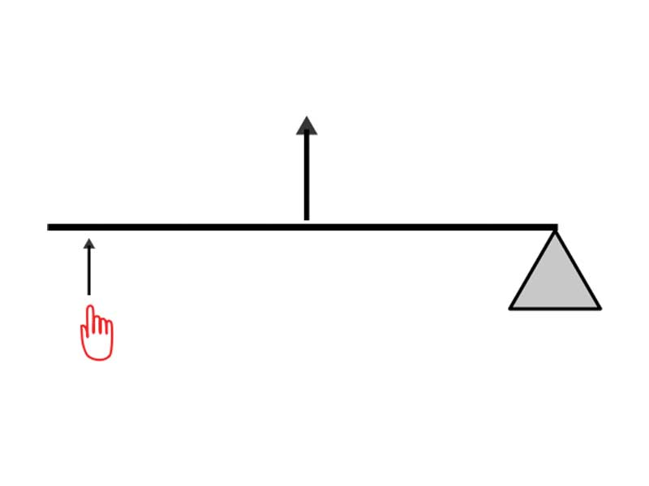

A

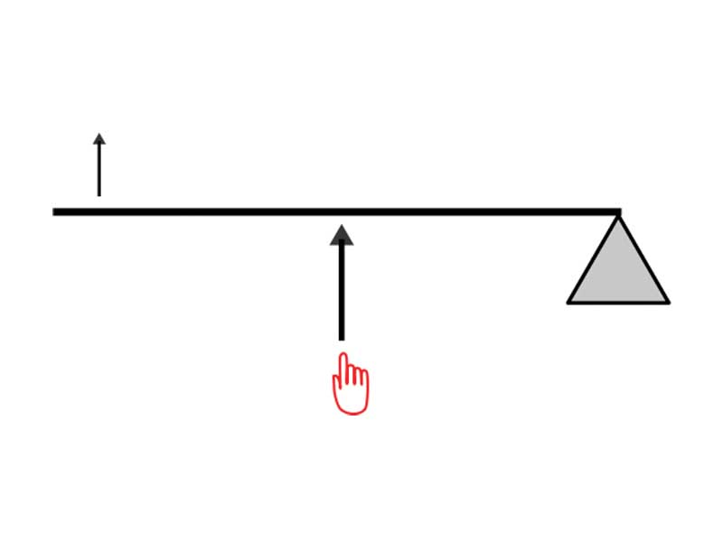

C

a) **Identify** the name of this type of simple machine ___________________________________

(1 marks)

b) **Identify** which class of this simple machine B is ____________________________________

(1 mark)

c) **Identify** the parts of this type of simple machine ___________________________________

___________________________________________________________________________

(3 marks)

9. The following table shows the results of a friction experiment.

|  |  |  |  |  |
| --- | --- | --- | --- | --- |
| Mass of Object (g) | Friction Force Measured (N) | | | Average Friction |
| Trial 1 | Trail 2 | Trial 3 |
| 100 | 2.1 | 2.1 | 1.8 |  |
| 200 | 3.9 | 4.0 | 4.1 |  |
| 300 | 5.7 | 6.3 | 6.0 |  |
| 400 | 7.8 | 7.8 | 8.4 |  |
| 500 | 9.9 | 9.9 | 10.2 |  |
| 600 | 12.1 | 11.9 | 12.0 |  |
| 700 | 14.2 | 13.7 | 14.1 |  |
| 800 | 16.0 | 15.9 | 16.1 |  |
| 900 | 17.7 | 18.1 | 18.2 |  |
| 1000 | 19.9 | 20.1 | 20.0 |  |

a) Graph the **average** results above as a line graph. (6 marks)

b) What was the **maximum** friction force measured in any trial? __________________

(1 mark)

c) What was the **range** in the average friction recorded? _________________________

(1 mark)

d) **Compare** the friction force of 200g and 700g ________________________________

___________________________________________________________________________

___________________________________________________________________________

(2 marks)

e) **Estimate** the average friction force if the mass is 1100g ________________________

(1 mark)

f) **Estimate** the average friction force if the mass is 650g _________________________

(1 mark)

10. **Define** the following:

i) Force ________________________________________________________________

___________________________________________________________________________

ii) Fulcrum _____________________________________________________________

___________________________________________________________________________

iii) Temporary magnet _____________________________________________________

___________________________________________________________________________

iv) Acceleration _________________________________________________________

___________________________________________________________________________

v) Atom ________________________________________________________________

___________________________________________________________________________

(5 marks)